INDIAN LPG CRISIS:-
LINK
CODE:-
import pandas as pd
import matplotlib.pyplot as plt
import seaborn as sns
data = pd.read_csv(r"F:\vs code\Training\10_Property_stolen_and_recovered.csv")
print(data)
x = data.head()
y = data.tail()
print(x)
print(y)
print(data.describe())
df = data[['Area_Name','Year','Cases_Property_Stolen','Cases_Property_Recovered']]
df.columns = ['AN','YR','CPS','CPR']
print(df.head())
print(df.tail())
today = df[df['YR'] == 2010]
print(today.head())
maxdt = today.sort_values(by='CPS', ascending=False)
print(maxdt)
tsd = maxdt[0:5]
print(tsd)
tsd = maxdt[0:10]
print(tsd)
sns.barplot(x='AN', y='CPS', data=tsd)
plt.xticks(rotation=90)
plt.show()
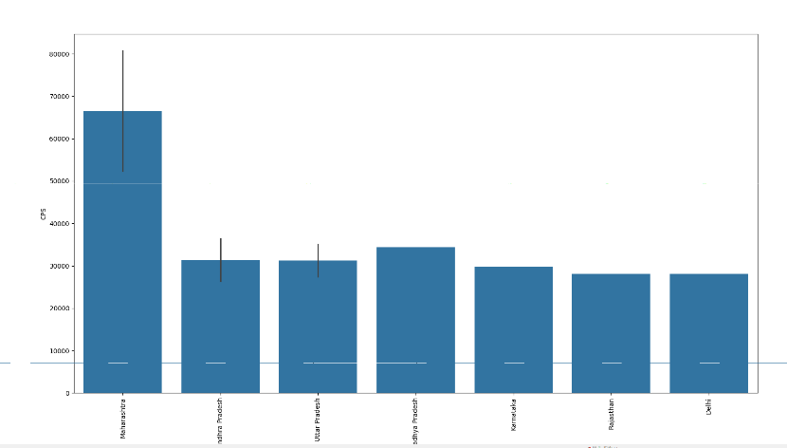
INDIAN DRIVING VOILATIONS:-
LINK
CODE:-
import pandas as pd
import matplotlib.pyplot as plt
import seaborn as sns
data=pd.read_csv(r"F:\vs code\Training\Road.csv\Road.csv")
print(data)
x=data.head()
y=data.tail()
print(x)
print(y)
print(data.describe())
df=data[['Day_of_week','Age_band_of_driver','Sex_of_driver','Number_of_casualties','Cause_of_accident','Accident_severity']]
df.columns=['DW','ABD','SD','NC','CA','AS']
print(df.head())
print(df.tail())
today=df.groupby('DW')['NC'].sum().reset_index()
print(today)
maxdt=today.sort_values(by='NC',ascending=False)
print(maxdt)
tsd=maxdt[0:5]
print(tsd)
tsd=maxdt[0:7]
print(tsd)
sns.barplot(x='DW',y='NC',data=tsd)
plt.xticks(rotation=45)
plt.show()
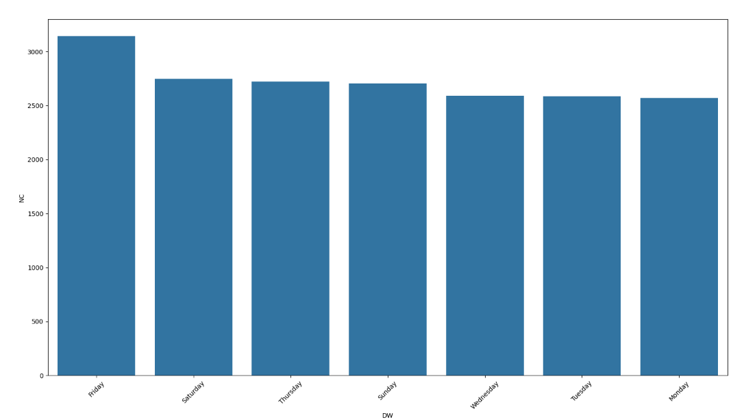

CANCER DATASET :-
LINK

import pandas as pd
import matplotlib.pyplot as plt
import seaborn as sns
data=pd.read_csv(r"F:\vs code\Training\cancer_data_dashboard.csv")
print(data)
x=data.head()
y=data.tail()
print(x)
print(y)
print(data.describe())
df=data[['id','diagnosis','radius_mean','texture_mean','perimeter_mean','area_mean','concavity_mean','symmetry_mean','radius_worst','area_worst']]
df.columns=['ID','DG','RM','TM','PM','AM','CM','SM','RW','AW']
print(df.head())
print(df.tail())
today=df.sort_values(by='AM',ascending=False)
print(today.head())
tsd=today.head(20)
print(tsd)
sns.barplot(x='ID',y='AM',data=tsd)
plt.xticks(rotation=90)
plt.show()
